STORED PROCEDURE LOGGING

EXEC Stored Procedure [dbo].[USP_Step_Log].sql dbo.PROCEDURESTEPLOG

 ✓Task 1

 ✓Start

Error

✓Finish Start

✓Task 2

✓Start Finish

**X** Error

Finish Start

Task 3 Error

Start

Error

Finish

Stored Procedures created by users who want logging will call [dbo].[USP_Step_Log] to log the start, execution and completion of each process in the stored procedure as the logging stored procedure is called. A timestamp will be entered into the logging table (dbo.PROCEDURESTEPLOG) along with all information that was supplied to the variables.

Each stored procedure will use a TRY ... CATCH…THROW block of code around each new process in the Stored Procedure to capture error events and log them. When an error is thrown, it is captured in the table and the Stored Procedure will halt execution.

The calling stored procedure will log these values from the variables if values have been supplied at the time it is called.

Variables:

@ProcedureName VARCHAR(100) THE FULLY QUALIFIED STORED PROCEDURE NAME

(DATABASENAME.SCHEMA.STOREDPROCEDURENAME)

@Variables VARCHAR(150) THE RUNTIME VARIABLES

@StepDesc VARCHAR(100) = NULL IDENTIFIES RUNNING PROCESS

@RowsAffected INT = NULL SET TO @@ROWCOUNT

@ErrorLine INT = NULL SET TO @ERROR_LINE

@ErrorMessage VARCHAR(4000) = NULL SET TO @ERROR_MESSAGE

@ErrorSQLCode VARCHAR(500) = NULL INCLUDE YOUR SQL CODE

@AdditionalInfo VARCHAR(500) = NULL ANY HELPFUL PROCESS INFO

@RunID INT CURRENT RUNID NUMBER

@CreatedBy VARCHAR(50) PERSON WHO STARTED PROCESS

@ApplicationID SMALLINT BATCHID NUMBER

An example of how the stored procedure is executed:

EXEC Apollo_Log.dbo.USP_Step_Log

@ProcedureName=’APOLLO_NDM.dbo.SomeProcedure’

,@ApplicatiomID = 234

,@RunID = 423

,@StepDesc = 'Step 3 of 9 Address Dedup'

,@RowsAffected = @@ROWCOUNT

An example of how it is called within a stored procedure:

AS

BEGIN

SET NOCOUNT ON;

DECLARE @ERROR_LINE INT

DECLARE @ERROR_MSG VARCHAR(4000)

--------------------------------New Process Step 1

--START PROCESS LOGGING

EXEC Apollo_Log.dbo.USP_Step_Log

@ProcedureName = ' '

,@Variables = ' '

,@StepDesc = ' '

,@RowsAffected= @@ROWCOUNT

,@AdditionalInfo = ' '

,@RunID = 0

,@CreatedBy = ' '

,@ApplicationId = 0

;

BEGIN TRY

---------------------------------------------

SELECT 'Put Code Here';---ENTER YOUR PROCESS CODE HERE

---------------------------------------------

END TRY

BEGIN CATCH

SET @ERROR_LINE = ERROR_LINE()

SET @ERROR_MSG = ERROR_MESSAGE();

--CATCH ERROR LOGGING

EXEC Apollo_Log.dbo.USP_Step_Log

@ProcedureName = ' '

,@Variables = ' '

,@ErrorLine = @ERROR_LINE

,@ErrorMessage = @ERROR_MSG

,@RowsAffected= @@ROWCOUNT

,@CreatedBy = ' '

,@ApplicationId = 0

;

THROW;

END CATCH

--COMPLETION OF PROCESS LOGGING

EXEC Apollo_Log.dbo.USP_Step_Log

@ProcedureName = ' '

,@Variables = ' '

,@StepDesc = ' '

,@RowsAffected= @@ROWCOUNT

,@AdditionalInfo = ' '

,@RunID = 0

,@CreatedBy = ' '

,@ApplicationId = 0

;

--------------------------------New Process Step 2

Example of data logged in Rows:

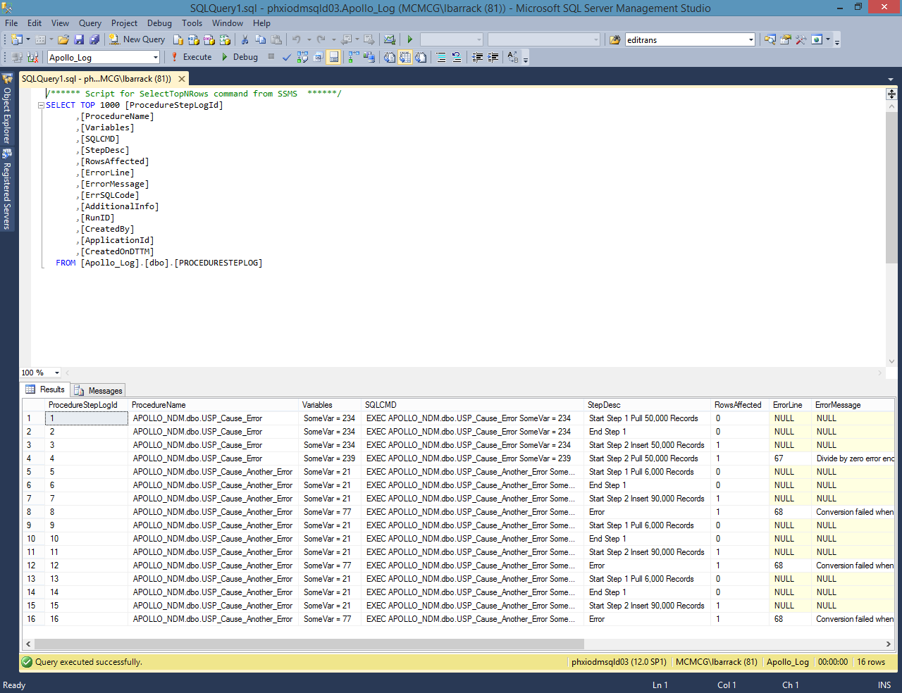

Rows Continued:

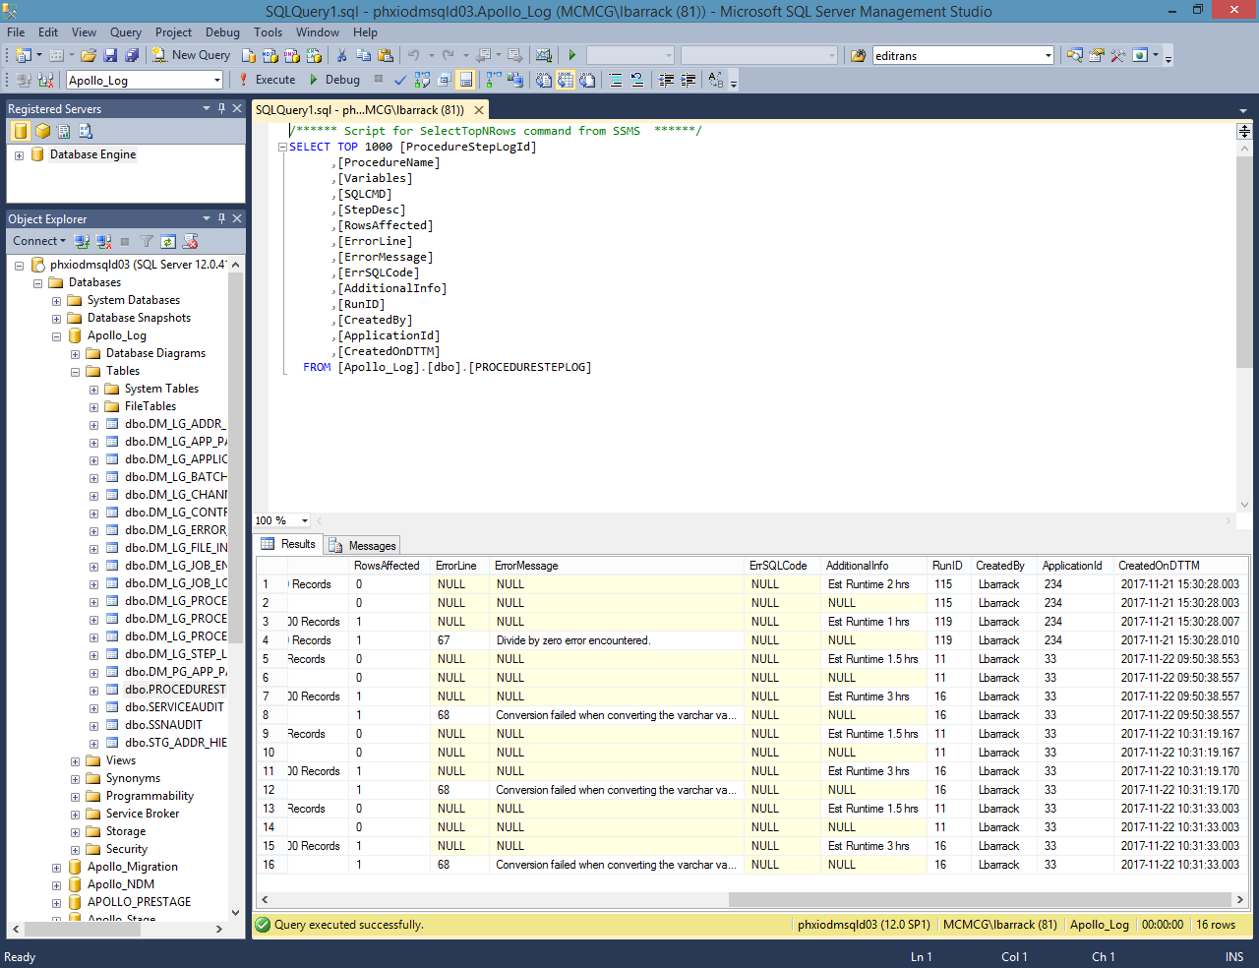

**Installation**

The following scripts need to be run for the APOLLO_LOG database:

Create tbl PROCEDURESTEPLOG.Table – creates the table that stores all the logging data and a clustered key

on the timestamp.

[dbo].[USP_Step_Log].sql - creates the logging stored procedure. Users must have the GRANT EXECUTE permission.

[dbo].[USP_Procedure_Step_Log_Template].sql - creates the stored procedure template used as guidance

on how to add logging to a stored procedure.